Alba de los Angeles Calero

Piedre Rajada, Ciudad Darío, Nicaragua

Education – Teacher Because of Rainbow Network Scholarships

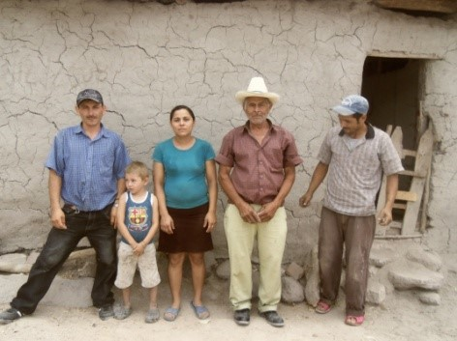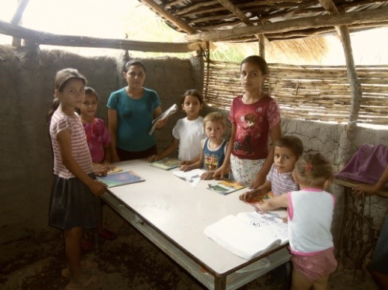

Alba de los Angeles Calero grew up in the tiny community of Piedre Rajada, where the 135 residents live in homes with dirt floors and mud walls and almost no one had an education.

Today, Alba is helping to change all that.

When Rainbow Network arrived in the remote mountain community in 2007, Alba was already a young woman. She was resigned to not being able to continue her studies because of her family’s extreme poverty. Despite a gap of several years since she had completed elementary school, she was thrilled with the chance to attend high school on a Rainbow Network scholarship. Although she also has two brothers, Alba was the only one in her very poor family to get an education. Her brothers went to work in the fields as soon as they finished elementary school to help support their elderly parents.

To get her education, Alba had to walk the 7 kilometers to the Normal Mount Zion School in the El Prado community. Then, like all Rainbow Network scholarship students, she would tutor the younger children back in Piedre Rajada. She grew to love education and teaching, and she did so well that she earned a Rainbow Network scholarship to attend the National Institute to get her teaching degree. That meant she had to walk a mile and get on a bus to travel the 30 miles to school. Despite often inaccessible roads during the rainy season, Alba never gave up her dream.

Now she teaches about 40 students in the same school she attended at El Prado. She still walks or rides her bicycle the 7 kilometers. And she still teaches the children of Piedre Rajada and teaches adults how to read and write. She helps the Rainbow Network doctors during patient consultations by searching out the appropriate record, following the example of her mother who is an active volunteer and cooks in the community nutrition center.

Alba and the other residents of Piedre Rajada are excited about the future for their community and they wanted to show their appreciation.

It was a dry February day when Johnny Moneymaker and his wife, Linda, were surprised by the the residents of the little community. Johnny, who is a Rainbow Network board member and longtime supporter, learned about the need for a new school and community center in Piedre Rajada. He pledged that if the community could get the land he would provide the materials to build the center.

When Rainbow Network Nicaragua Director Nelson Palacio took an unexpected turn down a familiar dirt road off the highway, Johnny and Linda saw a group of people carrying a large handwritten sign. They worried that it was some type of protest, but as they drew closer, they saw that the sign was thanking them for their support. The group of Piedre Rajada residents had been waiting out in the sun to share their excitement about the new community center they will build on the very land they were standing by. The land had been donated by an elderly woman in the village, and she was there to give Johnny a hug.

Everyone walked back up to the village where Alba was inside a small, dark adobe building filled with desks and children, all doing school work. The children grinned as the tall American stepped inside. Two girls stood up and sang a duet, thanked Johnny and told him that they are praying for him.

The usually stoic Johnny was brought to tears. His voice cracked as he said that he just wanted to thank Jesus for bringing them together.

Alba stood smiling because she knew that the work of Rainbow Network, in the name of Jesus Christ, has made such a difference for her and her community. The new center will not only house her little school, it will be used as a nutrition center, medical clinic, meeting place and worship center.

Alba’s own life mirrors the life of her community. Before Rainbow Netwrok arrived, she was destined to a life of poverty, with only a basic elementary education. “If you have an education and food, those two things are basic,” she said. “We didn’t have that before.”

She understood the importance of organizing to work with Rainbow Network in 2007 when she was only about 20 years old. She stepped up as a community leader. Now she is helping her family and her community by contributing as a teacher and a leader.

“Before, it was difficult to find a teacher to teach in the community,” she said. “Now, thanks to God and Rainbow Network, there are two teachers, both of us from the community. That is an achievement.”

With education, healthcare and economic development through Rainbow Network micro loans available in Piedre Rajada, the community can see a much brighter future. If land can be secured, a Rainbow Network housing project could mean people like Alba could get their own home instead of living with eight people in one small house, and others who need better housing could move into a secure Rainbow Network home.

Alba is now the mother of 1-year-old Juan Carlos, and she has dreams for her son. “My dream is that, hopefully, I will be able to save money to provide for his education,” she said. “If not, I will apply for a Rainbow Network scholarship so that he can get an education like I did.”

The scholarships, schools, nutrition centers, medical clinics and micro loans that are available to Rainbow Network communities have made a difference in Alba’s life and the life of Piedre Rajada. Alba loves to tell people about the many benefits that Rainbow Network provides.

“I would tell people that with the love and care that we get from Rainbow Network, we have a better life and a safer place.”

